**SUBJECT: CULTURAL AND CREATIVE ART**

**ALPHA TERM**

**SCHEME OF WORK JSS2**

**WEEK TOPIC**

|  |  |
| --- | --- |
| **1.** | **ELEMENTS OF DESIGN/ART** |
| **2.** | **HISTORY OF MUSIC** |
| **3.** | **DESIGN IN THEATRE** |
| **4.** | **DANCE** |
| **5.** | **SELF CONTROL** |
| **6.** | **PRINCIPLES OF DESIGN/ART** |
| **7.** | **HISTORY OF MUSIC** |
| **8.** | **THE STUDY OF COLOUR** |
| **9.** | **VOICE TRAINING** |
| **10.** | **THE STUDY OF COLOURS (COLOUR APPLICATION)** |
| **11.** | **LISTENING AND MUSIC APPRECIATION** |
| **12/13** | **REVISION/EXAMINATION** |

**WEEK 1 CLASS: J.S.S.**

**TOPIC: ELEMENTS OF ART/DESIGN.**

# Element of art means the things or items that constitute an art or artworks .They are the ingredients that make up an art work.

The elements and principles of design are the building blocks used to create a work of art. The elements of design can be thought of as the things that make up a painting, drawing, design etc. Good or bad - all paintings will contain most of if not all, the seven elements of design.

A work of art can be analyzed by considering a variety of aspects of it individually. These aspects are often called the **elements of art**. A commonly used list of the main elements include form, line, color, space and texture.

## Line

[Lines](https://en.wikipedia.org/wiki/Line_(geometry)) and [curves](https://en.wikipedia.org/wiki/Curve) are marks that span a distance between two points (or the path of a moving point). As an element of visual art, line is the use of various marks, outlines and implied lines in artwork and design. A line has a width, direction, and length.[[1]](https://en.wikipedia.org/wiki/Elements_of_art#cite_note-getty-1) A line's width is sometimes called its "thickness". Lines are sometimes called "strokes", especially when referring to lines in digital artwork.

## Form

The form of a work is its shape, including its volume or perceived volume. A [three-dimensional](https://en.wikipedia.org/wiki/Three-dimensional_space) artwork has depth as well as width and height. Three-dimensional form is the basis of [sculpture](https://en.wikipedia.org/wiki/Sculpture). However, [two-dimensional](https://en.wikipedia.org/wiki/Two-dimensional_space) artwork can achieve the illusion of form with the use of [perspective](https://en.wikipedia.org/wiki/Perspective_(visual)) and/or [shading](https://en.wikipedia.org/wiki/Shading) or modelling techniques. [Formalism](https://en.wikipedia.org/wiki/Formalism_(art)) is the analysis of works by their form or shapes in [art history](https://en.wikipedia.org/wiki/Art_history) or [archeology](https://en.wikipedia.org/wiki/Archeology).

## Colour

[Colour](https://en.wikipedia.org/wiki/Colour) is the element of art that is produced when light, striking an object, is reflected back to the eye. There are three properties to colour. The first is [hue](https://en.wikipedia.org/wiki/Hue), which simply means the name we give to a colour (red, yellow, blue, green, etc.). The second property is intensity, which refers to the vividness of the colour. A colour's intensity is sometimes referred to as its "[colourfulness](https://en.wikipedia.org/wiki/Colourfulness)", its "saturation", its "purity" or its "strength".The third and final property of colour is its [value](https://en.wikipedia.org/w/index.php?title=Value_(colourimetry)&action=edit&redlink=1), meaning how light or dark it is. The terms [shade and tint](https://en.wikipedia.org/wiki/Tints_and_shades) refer to value changes in colours. In painting, shades are created by adding black to a colour, while tints are created by adding white to a colour.

## Space

Space is an area that an artist provides for a particular purpose. Space includes the background, foreground and middle ground, and refers to the distances or area(s) around, between, and within things. There are two kinds of space: [negative space](https://en.wikipedia.org/wiki/Negative_space) and positive space. Negative space is the area in between, around, through or within an object. Positive spaces are the areas that are occupied by an object and/or form.

**Texture**

Texture, another element of art, is used to describe either the way a work actually feels when touched, or the depiction of textures in works, as for example in a painter's rendering of colour.

**WEEK 2 CLASS: J.S.S. 2**

**TOPIC: HISTORY OF MUSIC**

**Music theory** Music theory is the study of the practices and possibilities of music. It generally derives from observation of how musicians and composers make music, but includes hypothetical speculation. Most commonly, the term describes the academic study and analysis of fundamental elements of music such as pitch, rhythm, harmony, and form, but also refers to descriptions, concepts, or beliefs related to music. Because of the ever-expanding conception of what constitutes music (see Definition of music), a more inclusive definition could be that music theory is the consideration of any sonic phenomena, including silence, as it relates to music.

# History of Music

## Pre-Renaissance Music: The Evolution of Instruments and Theory

### Prehistoric Music.

The earliest forms of music were probably drum-based, percussion instruments being the most readily available at the time (i.e. rocks, sticks). These simplest of simple instruments are thought to have been used in religious ceremonies as representations of animals. There was no notation or writing of this kind of "music" and its sounds can only be extrapolated from the music of (South) American Indians and African natives who still adhere to some of the ancient religious practices.

As for the more advanced instruments, their evolution was slow and steady. It is known that by 4000 BCE the Egyptians had created harps and flutes, and by 3500 BCE lyres and double-reeded clarinets had been developed.

In Denmark, by 2500 BCE an early form of the trumpet had been developed. This trumpet is what is now known as a "natural trumpet." It is valve less, and depends completely on manipulation of the lips to change pitch.

One of the most popular instruments today was created in 1500 BCE by the Hittites. I am talking about the guitar. This was a great step; the use of frets to change the pitch of a vibrating string would lead to later instruments such as the violin and harpsichord.

In 800 BCE the first recovered piece of recorded music was found. It was written in cuneiform and was a religious hymn. It should be noted that cuneiform is not a type of musical notation.

By 700 BCE there are records of songs that include vocals with instrumentals. This added a whole new dimension to music: accompaniment.

### Music in Ancient Rome and Greece

Greece was the root of all Classical art, so it's no coincidence that Classical music is rooted in Grecian innovations. In 600 BCE, famed mathematician Pythagoras dissected music as a science and developed the keystone of modern music: the octave scale. The importance of this event is obvious. Music was a passion of the Greeks. With their surplus of leisure time (thanks to slave labor) they were able to cultivate great artistic skills. Trumpet competitions were common spectator events in Greece by 400 BCE. It was in Greece that the first bricks in music theory's foundation were layer. Aristotle wrote on music theory scientifically, and brought about a method of notation in 350 BCE. The work of that genius is still studied today.

The next significant step in music's evolution was by Boethius. In 521 CE he brought the Greek system of notation to Western Europe, allowing the musicians there to scribe accurately the folk songs of their lands. Incidentally, it was Boethius who first wrote on the idea of the opera.

### Music in the Middle Ages

Most of the music created after Rome fell was commissioned by the church. The Catholic religion has a long history of involvement (for better or worse) with the musical arts. In 600 CE Pope Gregory had the Schola Cantarum built. This was the first music school in Europe.

Meanwhile in China, music was progressing also: it was reported that in 612 CE there were orchestras with hundreds of musicians performing for the assorted dynasties. Although the specific music from this period in China is unknown, the distinct style supposed to have developed there is reflected even in recent orchestral Asiatic pieces.

In 650 CE a new system of writing music was developed using "neumes" as a notation for groups of notes in music.

144 years after the Schola Cantarum was built, a singing school opened in the Monastery of Fuda, fueling the interest in musical vocation. And by 790 CE, there were splinters of the Scholar Cant arum in Paris, Cologne and Metz. In 800 CE the great unifier Charlemagne had poems and psalms set to music. In 850 CE Catholic musicians had a breakthrough by inventing the church "modes." These modes would later metamorphose into today's major and minor scales. In 855 CE, the first polyphonic (2 unrelated melodies/voices at once) piece was recorded, and by 1056 this polyphonic style replaced Gregorian chants as the music of choice (even after the Church made polyphonic music "illegal"; this ban was later lifted). In 980 CE, the great tome Antiphononium Codex Montpellier was scribed.

## THE RENAISSANCE

On the dawn of the Renaissance in 1465 the printing press was first used to print music. By using a press a composer could organize his pieces and profit from them with great ease. In 1490 Boethius's writings on opera were republished in Italian.

With the onset of the Renaissance, the rules of music were about to change drastically. This was the beginning of a new enlightened age that would showcase some of the greatest musical minds ever produced.

The history of music at this point is best told by the [styles](https://method-behind-the-music.com/history/styles/) that emerged and the [composers](https://method-behind-the-music.com/history/composers/) who lived after the Renaissance.

**Art and music**

The [Venus of Willendorf](https://en.wikipedia.org/wiki/Venus_of_Willendorf) is one of the most famous Venus figurines.Early examples of artistic expression, such as the [Venus of Tan-Tan](https://en.wikipedia.org/wiki/Venus_of_Tan-Tan) and the patterns found on [elephant](https://en.wikipedia.org/wiki/Elephant) bones from [Bilzingsleben](https://en.wikipedia.org/wiki/Bilzingsleben_%28Paleolithic_site%29) in [Thuringia](https://en.wikipedia.org/wiki/Thuringia), may have been produced by Acheulean tool users such as [*Homo erectus*](https://en.wikipedia.org/wiki/Homo_erectus) prior to the start of the [Middle Paleolithic](https://en.wikipedia.org/wiki/Middle_Paleolithic) period. However, the earliest undisputed evidence of art during the Paleolithic period comes from [Middle Paleolithic](https://en.wikipedia.org/wiki/Middle_Paleolithic)/[Middle Stone Age](https://en.wikipedia.org/wiki/Middle_Stone_Age) sites such as [Bombs Cave](https://en.wikipedia.org/wiki/Blombos_Cave) –[South Africa](https://en.wikipedia.org/wiki/South_Africa)– in the form of [bracelets](https://en.wikipedia.org/wiki/Bracelet), [beads](https://en.wikipedia.org/wiki/Bead), [rock art](https://en.wikipedia.org/wiki/Rock_art), and [ochre](https://en.wikipedia.org/wiki/Ochre) used as body paint and perhaps in ritual.[[35]](https://en.wikipedia.org/wiki/Paleolithic#cite_note-Miller2006-35)[[47]](https://en.wikipedia.org/wiki/Paleolithic#cite_note-Henahan-47) Undisputed evidence of art only becomes common in the following Upper Paleolithic period.

**WEEK 3**

**TOPIC: DESIGN IN THEATRE**

**CLASS: J.S.S. 2**

**Theatre Design**

Theatre design or scenography is the design of the space in which a performance takes place. Theatre designers create stage pictures, that is to say, they design the space, costume and props that you see when you watch a performance.

Some designers deal only with set or costumes, particularly if it is a very large scale production such as an opera, but in this country designers generally create designs for both.  
In recent times we have started to more readily adopt the term scenographer. This alternative name for theatre design is used more widely in the rest of the world. It seeks to give a more holistic description of what designers do and can encompass not just set, costume and prop design but sound, lighting and multi-media design for performance as well.

Most theatre design courses will now include modules in these elements in order to equip you with the appropriate skills to work in a broad range of performance-related environments. If you want to specialize in these elements from the outset however, then courses in technical theatre would be a more advisable route.

Scenography/theatre design also encompasses work made for a specific site or location. This can be indoors or out and can be referred to as site-specific or landscape theatre.  
Increasingly designers are also using their skills in areas such as creative events, parades, opening ceremonies etc., pop concerts, or as part of the process of the wider regeneration of cities and communities. This kind of work often supplements more traditional theatre work which still pays comparatively low fees.

Theatre design or scenography is the design of the space in which a performance takes place. Theatre designers create stage pictures, that is to say, they design the space, costume and props that you see when you watch a performance.

Some designers deal only with set or costumes, particularly if it is a very large scale production such as an opera, but in this country designers generally create designs for both.  
In recent times we have started to more readily adopt the term stenographer. This alternative name for theatre design is used more widely in the rest of the world. It seeks to give a more holistic description of what designers do and can encompass not just set, costume and prop design but sound, lighting and multi-media design for performance as well.

Most theatre design courses will now include modules in these elements in order to equip you with the appropriate skills to work in a broad range of performance-related environments. If you want to specialize in these elements from the outset however, then courses in technical theatre would be a more advisable route.

Scenography/theatre design also encompasses work made for a specific site or location. This can be indoors or out and can be referred to as site-specific or landscape theatre.

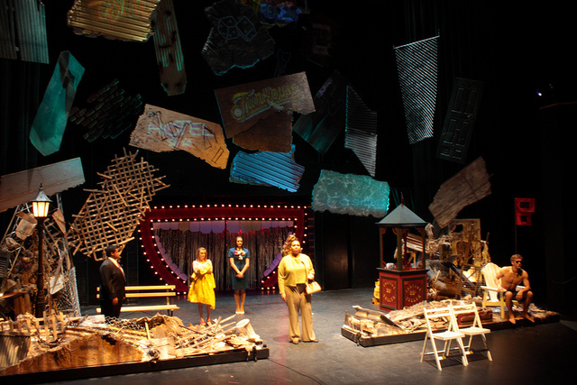

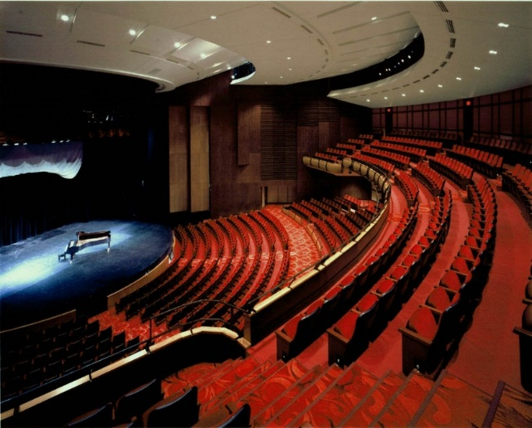

**WEEK 4 CLASS: J.S.S. 2**

**TOPIC: DANCE**

**DANCE**.

In the context of performing arts, [dance](https://en.wikipedia.org/wiki/Dance) generally refers to human [movement](https://en.wikipedia.org/wiki/Motion_(physics)), typically rhythmic and to music, used as a form of audience entertainment in a [performance](https://en.wikipedia.org/wiki/Performance) setting. Definitions of what constitutes [dance](https://en.wikipedia.org/wiki/Dance) are dependent on [social](https://en.wikipedia.org/wiki/Society), [cultural](https://en.wikipedia.org/wiki/Culture), [aesthetic](https://en.wikipedia.org/wiki/Aesthetic) [artistic](https://en.wikipedia.org/wiki/Artistic) and moral constraints and range from functional movement (such as [folk dance](https://en.wikipedia.org/wiki/Folk_dance)) to codified, virtuoso techniques such as [ballet](https://en.wikipedia.org/wiki/Ballet).

Dance is any body movement home or space for express human emotion in reaction to musical performance anywhere. It is an organized movement of the body to musical rhythm. It could be for fun to narrate a story, to inform or entertain.

Dance is a powerful impulse, but the art of dance is that impulse channeled by skillful performers into something that becomes intensely expressive and that may delight spectators who feel no wish to dance themselves. These two concepts of the art of dance—dance as a powerful impulse and dance as a skillfully choreographed art practiced largely by a professional few—are the two most important connecting ideas running through any consideration of the subject. In dance, the connection between the two concepts is stronger than in some other arts, and neither can exist without the other.

[Choreography](https://en.wikipedia.org/wiki/Choreography) is the art of making dances, and the person who practices this art is called a choreographer.



**STRUCTURE OF DANCE**

Dance has three basic structures, they are:

1. **The beginning:** This includes entry warm up and first impression.
2. **The middle:** This includes dancing proper and the climax.
3. **The end:** This includes rounding off last impression and exists.

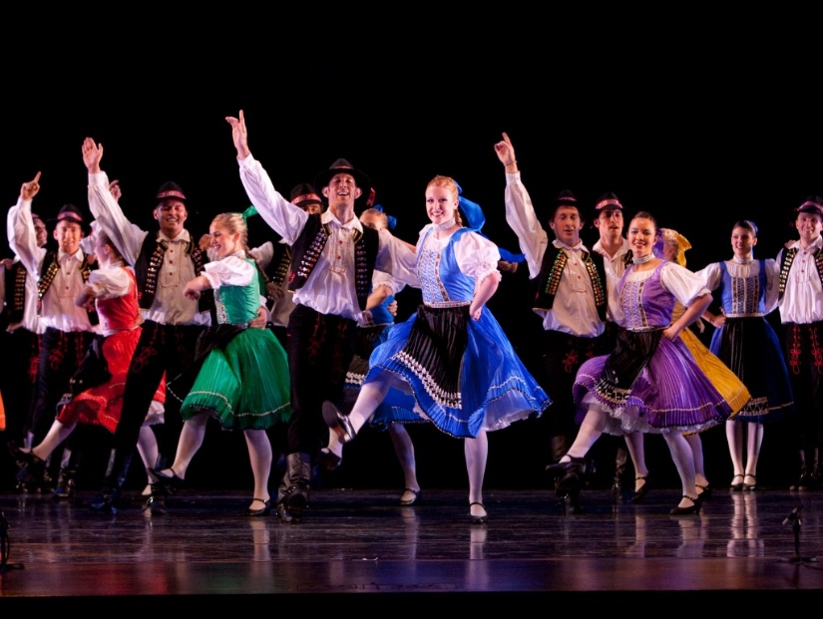

**WEEK 5 CLASS: J.S.S. 2**

**TOPIC: SELF CONTROL**

**Self-control** is the ability to [control one's emotions](https://en.wikipedia.org/wiki/Emotional_self-regulation), [behavior](https://en.wikipedia.org/wiki/Behavior), and [desires](https://en.wikipedia.org/wiki/Desire) in the face of external demands, to function in society.  Self-control is essential in behavior to achieve [goals](https://en.wikipedia.org/wiki/Goal) and to avoid impulses and/or emotions that could prove to be negative or destructive.

In [psychology](https://en.wikipedia.org/wiki/Psychology) it is sometimes called [self-regulation](https://en.wikipedia.org/wiki/Emotional_self-regulation), although that is itself a some what broader concept.

In [behavior analysis](https://en.wikipedia.org/wiki/Behavior_analysis) self-control represents the locus of two conflicting contingencies of [reinforcement](https://en.wikipedia.org/wiki/Reinforcement), which then make a *controlling response* reinforcing when it causes changes in the *controlled response*. Self-control is like a muscle. In the short term, overuse of self-control will lead to depletion.

However, in the long term the use of self-control can strengthen and improve over time.

### Benefits of Self-Control

#### 1. INCREASES DECISION MAKING CAPACITY

When we exercise self-control after making a decision it becomes more difficult. When we practice self-control first, it becomes easier to make decisions because our minds switch to simpler processes. For example, a dieter may avoid a donut first thing in the morning but after making tough decisions about work and life all day, their self-control may have slipped by the time they should say no to cake as dessert after dinner.

#### 2. INCREASES CHANCES OF SUCCESS

Research at Duckworth Lab at the University of Pennsylvania’s positive psychology center concluded that when self-control was measured against talent over time the ones that practiced grit rather than relying on talent came out as more successful. For example, in an experiment carried out between two groups at West Point, those that relied on self-control had a better chance at being able to move past the first summer of intense trials over those that had domain relevant talents such as physical fitness.

#### 3. SELF-CONTROL CAN HELP US CURTAIL IMPULSIVE BEHAVIORS SUCH AS LYING AND BINGE DRINKING

In a study conducted by Meldrum et al. A group of 1600 adolescents in US schools were asked if they had taken a fictitious drug and if so, how frequently.

Out of the participants, 40 said that they were familiar with the medicine and had taken it in the past.  
This goes to show that some people can’t help lying and those that have low self-control are more likely to succumb to the impulse even if, like in this situation, they have nothing to gain from it.

#### 4. IMPROVES FOCUS

In a study by Bertram et al., participants were asked to solve math problems while under pressure. The participants that were evaluated as having low self-control were distracted by negative thoughts and did much poorer than their disciplined counterparts.

Self-control allows us to focus our energies on the task at hand and tune out distractions which make sure we perform to the best of our abilities. It also allows us to kick those negative thoughts out of our head, a major impediment to long term success.

#### 5. MORE LIKELY TO GET RICH

Although self-control is not the end all be all when it comes to making millions, it is an incredibly significant factor.

In a study conducted in New Zealand that shadowed 1,000 children over the course of 30 years. It was determined that those who had high levels of self-control went on to land high income jobs and had significantly lower levels of addiction. Only 10% of the children with developed discipline were in low income jobs as opposed to over 30% of those with poor discipline being in low income jobs.

#### 6. PROMOTES CONGRUENCE

Have you ever held two conflicting desires in your mind like wanting to eat a the last piece of red velvet cake after dinner but at the same time wanting to drop a few pounds?

People that are able to practice self-control have more harmonious lives because they avoid situations in which they have to choose between desires.

Instead of fighting with themselves over eating the last piece of cake to stick to their diet, they would not have bought the cake in the first place and therefore prevent themselves from being exposed to conflicting desires.

**WEEK 6 CLASS: J.S.S. 2**

**TOPIC: PRINCIPLES OF ART/DESIGN**

# Principles of design are the concept used to arrange the elements of design. They are also referred to as principles of organization. They are the rules used to organize the elements of art in a design work.

|  |  |
| --- | --- |
|  | The Principles of design can be defined of as what we do to the elements of design.  How we apply the Principles of design determines how successful we are in creating a work of art.  **NOTE** - the  hyperlinks within the text of this page will open information in a new browser window. After you have read that information the window can then be closed leaving this window open.  **THE PRINCIPLES OF DESIGN**  **BALANCE** Balance in design is similar to balance in physics http://www.johnlovett.com/design1.jpg A large shape close to the center can be balanced  by a small shape close to the edge. A large light  toned shape will be balanced by a small dark toned  shape (the darker the shape the heavier it appears to be)  **GRADATION** Gradation of size and direction produce linear perspective. Gradation of of colour from warm to cool and tone from dark to light produce aerial perspective. Gradation can add interest and movement to a shape. A gradation from dark to light will cause the eye to move along a shape. http://www.johnlovett.com/design2.jpg  **REPETITION** Repetition with variation is interesting, without variation repetition can become monotonous.  http://www.johnlovett.com/repsq1.jpg  The five squares above are all the same. They can be taken in and understood with a single glance.  http://www.johnlovett.com/repsq2.jpg  When variation is introduced, the five squares, although similar, are much more interesting to look at. They can no longer be absorbed properly with a single glance. The individual character of each square needs to be considered.  If you wish to create interest, any repeating element should include a degree of variation.  **CONTRAST** Contrast is the juxtaposition of opposing elements eg. opposite colours on the colour wheel - red / green, blue / orange etc. Contrast in tone or value - light / dark. Contrast in direction - horizontal / vertical.  The major contrast in a painting should be located at the center of interest. Too much contrast scattered throughout a painting can destroy unity and make a work difficult to look at. Unless a feeling of chaos and confusion are what you are seeking, it is a good idea to carefully consider where to place your areas of maximum contrast.  **HARMONY** Harmony in painting is the visually satisfying effect of combining similar, related elements. eg. adjacent colours on the colour wheel, similar shapes etc.  **DOMINANCE** Dominance gives a painting interest, counteracting confusion and monotony. Dominance can be applied to one or more of the elements to give emphasis http://www.johnlovett.com/design3.jpg  **UNITY** Relating the design elements to the the idea being expressed in a painting reinforces the principal of unity.eg. a painting with an active aggressive subject would work better with a dominant oblique direction, course, rough texture, angular lines etc. whereas a quiet passive subject would benefit from horizontal lines, soft texture and less tonal contrast.  Unity in a painting also refers to the visual linking of various elements of the work. |

**WEEK 7 CLASS: J.S.S. 2**

**TOPIC: HISTORY OF MUSIC**

# History of music

**Music** is found in every known culture, past and present, varying widely between times and places. Since all people of the world, including the most isolated tribal groups, have a form of music, it may be concluded that music is likely to have been present in the ancestral population prior to the dispersal of humans around the world.

Consequently, music may have been in existence for at least 55,000 years and the first music may have been invented in Africa and then evolved to become a fundamental constituent of human life.

A culture's music is influenced by all other aspects of that culture, including social and economic organization and experience, climate, and access to technology. The emotions and ideas that music expresses, the situations in which music is played and listened to, and the attitudes toward music players and composers all vary between regions and periods. "[Music history](https://en.wikipedia.org/wiki/Music_history)" is the distinct subfield of [musicology](https://en.wikipedia.org/wiki/Musicology) and history which studies music (particularly [Western art music](https://en.wikipedia.org/wiki/Art_music)) from a chronological perspective.

### PREHISTORIC MUSIC

### Prehistoric music, is commonly called primitive music, it is the name given to all music produced in [preliterate](https://en.wikipedia.org/wiki/Literate) cultures ([prehistory](https://en.wikipedia.org/wiki/Prehistory)), beginning somewhere in very late [geological history](https://en.wikipedia.org/wiki/Geological_history). Prehistoric music is followed by [ancient music](https://en.wikipedia.org/wiki/Ancient_music) in most of Europe (1500 BC) and later music in subsequent European-influenced areas, but still exists in isolated areas.

Prehistoric music thus technically includes all of the world's music that has existed before the advent of any currently extant historical sources concerning that music,

for example, traditional [Native American music](https://en.wikipedia.org/wiki/Native_American_music) of preliterate tribes and [Australian Aboriginal music](https://en.wikipedia.org/wiki/Australian_Aboriginal_music). However, it is more common to refer to the "prehistoric" music of non-European continents – especially that which still survives – as [folk](https://en.wikipedia.org/wiki/Folk_music), indigenous or traditional music. The origin of music is unknown as it occurred prior to recorded history.

Some suggest that the origin of music likely stems from naturally occurring [sounds](https://en.wikipedia.org/wiki/Sound) and [rhythms](https://en.wikipedia.org/wiki/Rhythm). Human music may echo these [phenomena](https://en.wikipedia.org/wiki/Phenomena) using [patterns](https://en.wikipedia.org/wiki/Patterns), [repetition](https://en.wikipedia.org/wiki/Repetition_(music)) and [tonality](https://en.wikipedia.org/wiki/Tonality). Even today, some cultures have certain instances of their [music intending to imitate natural sounds](https://en.wikipedia.org/wiki/Sound_mimesis_in_various_cultures). In some instances, this feature is related to [shamanistic beliefs or practice](https://en.wikipedia.org/wiki/Imitation_of_sounds_in_shamanism). It may also serve entertainment (game) or practical (luring animals in hunt) functions.

It is probable that the first [musical instrument](https://en.wikipedia.org/wiki/Musical_instrument) was the [human voice](https://en.wikipedia.org/wiki/Human_voice) itself, which can make a vast array of sounds, from singing, [humming](https://en.wikipedia.org/wiki/Hum_(sound)) and [whistling](https://en.wikipedia.org/wiki/Whistling) through to [clicking](https://en.wikipedia.org/wiki/Click_consonant), [coughing](https://en.wikipedia.org/wiki/Cough) and [yawning](https://en.wikipedia.org/wiki/Yawn). In 2008 archaeologists discovered a bone flute in the [Hohle Fels](https://en.wikipedia.org/wiki/Hohle_Fels) cave near [Ulm](https://en.wikipedia.org/wiki/Ulm), [Germany](https://en.wikipedia.org/wiki/Germany). The five-holed flute has a V-shaped mouthpiece and is made from a vulture wing bone. The oldest known wooden pipes were discovered near [Greystones](https://en.wikipedia.org/wiki/Greystones), [Ireland](https://en.wikipedia.org/wiki/Ireland), in 2004. A wood-lined pit contained a group of six flutes made from yew wood, between 30 and 50 cm long, tapered at one end, but without any finger holes. They may once have been strapped together.

### ANCIENT MUSIC

### The prehistoric age is considered to have ended with the development of writing, and with it, by definition, prehistoric music. "Ancient music" is the name given to the music that followed. The "oldest known song" was written in [cuneiform](https://en.wikipedia.org/wiki/Cuneiform), dating to 3400 years ago from Ugarit. It was deciphered by Anne Draffkorn Kilmer, and was demonstrated to be composed in harmonies of thirds, like ancient and also was written using a [Pythagorean tuning](https://en.wikipedia.org/wiki/Pythagorean_tuning) of the [diatonic scale](https://en.wikipedia.org/wiki/Diatonic_scale). The oldest surviving example of a complete musical composition, including musical notation, from anywhere in the world, is the [Seikilos epitaph](https://en.wikipedia.org/wiki/Seikilos_epitaph).

Double pipes, such as those used by the [ancient Greeks](https://en.wikipedia.org/wiki/Music_of_ancient_Greece), and ancient bagpipes, as well as a review of ancient drawings on vases and walls, etc., and ancient writings (such as in Aristotle, *Problems,* Book XIX.12) which described musical techniques of the time, indicate polyphony. One pipe in the aulos pairs (double flutes) likely served as a [drone](https://en.wikipedia.org/wiki/Drone_(music)) or "keynote," while the other played melodic passages. Instruments, such as the seven holed flute and various types of stringed instruments have been recovered from the [Indus valley civilization](https://en.wikipedia.org/wiki/Indus_valley_civilization) archaeological sites.

The history of musical development in Iran ([Persian music](https://en.wikipedia.org/wiki/Persian_traditional_music)) dates back to the prehistoric era. The great legendary king, Jamshid, is credited with the invention of music. Music in Iran can be traced back to the days of the [Elamite Empire](https://en.wikipedia.org/wiki/Elamite_Empire) (2500-644 BC).

Fragmentary documents from various periods of the country's history establish that the ancient Persians possessed an elaborate musical culture. The [Sassanid](https://en.wikipedia.org/wiki/Sassanid)period (AD 226-651), in particular, has left us ample evidence pointing to the existence of a lively musical life in Persia. The names of some important musicians such as Barbod, Nakissa and Ramtin, and titles of some of their works have survived.

The [Early music](https://en.wikipedia.org/wiki/Early_music) era may also include contemporary but traditional or folk music, including [Asian music](https://en.wikipedia.org/wiki/Asian_music), Persian music, [music of India](https://en.wikipedia.org/wiki/Music_of_India), [Jewish music](https://en.wikipedia.org/wiki/Jewish_music), [Greek music](https://en.wikipedia.org/wiki/Greek_music), [Roman music](https://en.wikipedia.org/wiki/Music_of_ancient_Rome), the [music of Mesopotamia](https://en.wikipedia.org/wiki/Music_of_Mesopotamia), the [music of Egypt](https://en.wikipedia.org/wiki/Music_of_Egypt), and [Muslim music](https://en.wikipedia.org/wiki/Muslim_music).

Greek written history extends far back into [Ancient Greece](https://en.wikipedia.org/wiki/Ancient_Greece), and was a major part of ancient [Greek theater](https://en.wikipedia.org/wiki/Greek_theater). In ancient Greece, mixed-gender choruses performed for entertainment, celebration and spiritual reasons. Instruments included the double-reed [aulos](https://en.wikipedia.org/wiki/Aulos) and the plucked [string instrument](https://en.wikipedia.org/wiki/String_instrument), especially the special kind called a [kithara](https://en.wikipedia.org/wiki/Kithara).

Music was an important part of education in ancient Greece, and boys were taught music starting at age six.

**WEEK8 CLASS: J.S.S. 2**

**TOPIC: THE STUDY OF COLOUR**

***THEORY OF COLOURS***

Colors are the most appealing icons to anyone. Babies get attracted to colors only even when they have no concept of shapes. Just imagine what would be world without colors and God has created so much harmony and contrast in nature that they so many colors never look bad together.

[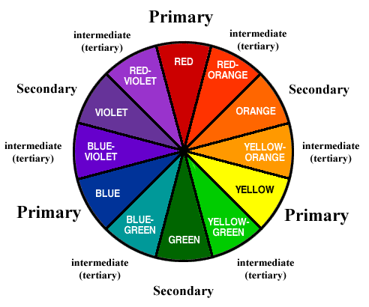](http://www.realmenrealstyle.com/color-wheel-menswear/)

Let’s classify the colors in the following categories:

* Primary Colors
* Secondary Colors
* Tertiary Colors

## PRIMARY COLORS

There are three primary colors,

1. Red,
2. Yellow
3. Blue

All colors are made out of these three colors.

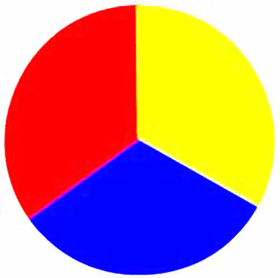

## SECONDARY COLORS

The mixture of yellow and blue makes GREEN,

The mixture of yellow and red makes ORANGE,

The mixture of red and blue makes PURPLE.

Green, Orange and Purple are secondary colors resulting from the mixture of primary colors.

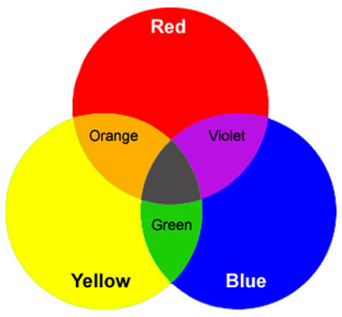

## Tertiary Colors

Tertiary colors are intermediate colors made out of secondary and primary colors. A tertiary color is a color made by mixing one primary color with one secondary color, in a given color space such as RGB or RYB.

Unlike primary and secondary colors, these are not represented by one firmly established name each. Brown and grey are sometimes known as Tertiary colors.

**WEEK 9 CLASS: J.S.S. 2**

**TOPIC: VOICE TRAINING**

|  |  |  |
| --- | --- | --- |
| |  |  | | --- | --- | | VOICE TRAINING |  | |
| Surely anyone can sing without vocal training?  Many people are gifted with natural singing ability, but whether you want to become a professional entertainer, a casual performer, or sing for fun, it is important to learn how protect your best asset and to increase it's potential. CAN YOU SING? Before you pay for tuition, take time to do the following steps   You will need:-  A Tape Recorder and Microphone.   Writing Materials.   Something to sing with - Use one of your favorite singles/backing track/midi file.   Record yourself singing along to a song.   Listen back to your recording.   Take notes on the following points:   Are you in Tune with the music? - your notes should match the song.   Is your voice weak or strong? - shouting is NOT Singing!!   Are you breathing correctly? - you should not be short of breath   Do you struggle to reach the notes - pick an easy song to start with!   Are you gasping for air between phrases - learn to breath in the "rests" between phrases   Record yourself again with another song   Listen to the difference in your practice recordings as you progress. |

**WEEK 10 CLASS: J.S.S. 2**

**TOPIC: THE STUDY OF COLOURS (COLOUR APPLICATION)**

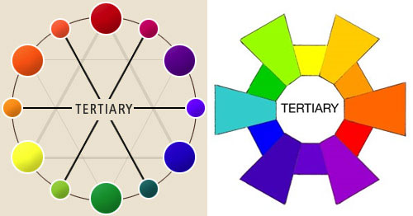

These examples very well illustrate how tertiary colors are made. The intermediate colors between primary and secondary colors.

## Classification of Colors

### Hue

Hue is the term used for the name of any color, e.g. yellow, orange, red, and blue all are hues. The main property of the color. In painting, hue is referred to as pure color. It might have many computing theories, but practically in design these theories are not as important to know as the color wheel.

Now what is a color wheel?

The answer can very well be explained by the following diagram:

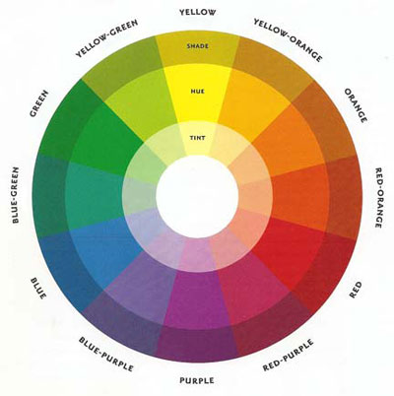

This figure completely tells you how primary colors become secondary and then tertiary, what is hue and then we will define what is tint and shade.

### INTENSITY

Intensity is the saturation or purity of the color, its brightness or dullness. In other words it’s the force of the color, full force might be a bright red color.



You can very well see the brightness and dullness of red color in this example. The more intense the color is, the brighter it is.

### Value

Value is the lightness or darkness of the color. The lightest value of the color is almost white and the darkest value is almost black.

There are two types of value:

1. Tint
2. Shade

**Tint** describes colors that are near white in value. Pink is a tint of red, which means white has been added. Similarly mauve is the tint of purple. Let’s see how these tints differ.



[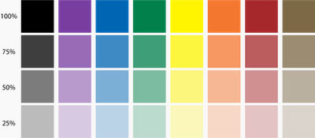](http://concoctionconspirator.blogspot.com/2009/05/cmyk-vs-pms.html)

As you keep on adding white to a certain color, the tints keep changing.

**SHADE**

 describes colors that are near black in value. Navy blue is the shade of blue. Similarly maroon is the shade of red.





As for black, grey and white colors, black and grey are neutral colors with no saturation. For printing purposes remember WHITE IS NOT A COLOR. White is only used as background color which the printer does not identify and it will never work on white color. The printers either use RGB mode i.e. red, green and blue or more professionally they use CMYK mode, i.e. cyan, magenta, yellow and black. Whatever color harmonies or color combinations you are selecting, make sure you exactly know the modes and values since percentages of colors can only be defined by modes.

## EMOTIONAL EFFECTS OF COLORS

Colors have different psychological effects, positive as well as negative. This point must be kept in mind while choosing colors in your design since various colors convey varied meanings.

### RED

Red is the color of energy, it’s bold, it’s powerful, it’s vibrant. It has the longest wavelength (the distance over which the wave’s shape repeats). It’s the color of effectiveness, excitement and liveliness. All over the world we follow red traffic light to stop, its visibility is the strongest amongst all other colors because of its highest wavelength. On the other hand its negative impacts can be aggression, visual disturbance and strain. You live in a red room for a day and you will go crazy, it has to be complimented with other colors to make it subtle.

### YELLOW

Yellow is a very emotional color, it is the color of self esteem, confidence and optimism. After red yellow has the longest wave length, appearing to be strong from a distance. World over yellow cabs can easily be seen, sunflowers, daffodils appear to be friendly. Contrary to this it also communicates few negative values like depression, hatred and anxiety.

### BLUE

Blue is the color of intelligence, vastness, royalty, serenity, coolness and tranquility. Sky appears blue and gives calm effect, water appears blue and gives peace of mind. Blue appears to be the favorite color of most of the people but on the other hand it is also a color of coldness, unfriendliness and unemotional.

### GREEN

Green is the most refreshing and cool color. Green is the color of life, fertility, reassurance, peace, harmony, balance. Nature is green and how soothing it is to our eyes. Not a single tree in this world is of the same green tint or shade, yet it appears to be so full of life and create environmental beauty.  As for its negative traits it is the color of Boredom, stagnation, blandness and enervation.

### VIOLET

Violet is color of truth, luxury and spiritual awareness. It has the shortest wavelength therefore it is considered to be weak also. A color of introversion and suppression. It is associated with deep contemplation and royalty, meditation and quality.

### ORANGE

Orange gives warmth, comfort, security, passion, fun and frolic. Due to the mixture of red and yellow it gives stimulation and sensuality. Use of too much orange gives a feeling of no serious attitude and gives a feeling of deprivation if used with black.

### PINK

Pink is a cute color, very feminine, love and tranquility. Though pink is a tint of red but it soothes rather than stimulates. It gives comfort and suggests grace and elegance. Sometimes too much pink looks physically weak and appears full of flaws. It creates impact of inhibition.

### GREY

Grey is a neutral color, not giving a direct psychological effect. It may represent emptiness and dullness. It gives impression of dampness and right tone of grey must be used otherwise it may make your composition depressive.

### BLACK

All colors are absorbed in black. Black is glamorous, graceful, efficient and security. Women wear black to attract, they look sophisticated. Black creates hindrance since there’s no light no reflection. It works perfectly with white thus the co relation is either alternation or repetition. Black is the color of mourning also. Too much black creates heaviness and scary look.

### WHITE

White is pure, clean, hygienic, innocent and simple. White is total reflection. It gives perception of space, too much clutter in a design can be overcome by using spaces of white. The negative effect of white is that it makes other colors used with it cold and unfriendly. Can create a diminishing effect.

### BROWN

Brown is the color of earth, rugged, serious, old, and ancient. Rustic look can very well be created with this color. Since brown is the combination of red and yellow with much larger percentage of black, it also gives the same seriousness as black but in a warmer way. It is natural and supportive but at the same time it is too non humorous and appears heavy.

**WEEK 11 CLASS: J.S.S. 2**

**TOPIC: LISTENING AND MUSIC APPRECIATION**

**Listening** is to give one's attention to sound. Listening involves complex affective, cognitive, and behavioral processes.

Affective processes include the motivation to attend to others; cognitive processes include attending to, understanding, receiving, and interpreting content and relational messages; and behavioural processes include responding with verbal and nonverbal feedback.

Listening differs from [obeying](https://en.wikipedia.org/wiki/Obedience_(human_behavior)). A person who receives and understands information or an instruction, and then chooses not to comply with it or to agree to it, has listened to the speaker, even though the result is not what the speaker wanted.

 Listening is a term in which the listener listens to the one who produced the sound to be listened.

## Barthes

Semiotician [Roland Barthes](https://en.wikipedia.org/wiki/Roland_Barthes) characterized the distinction between listening and hearing as "Hearing is a physiological phenomenon; listening is a psychological act." Hearing is always occurring, most of the time subconsciously. In contrast, listening is the interpretative action taken by the listener in order to understand and potentially make meaning out of the sound waves. Listening can be understood on three levels: alerting, deciphering, and an understanding of how the sound is produced and how the sound affects the listener.

Alerting, the first level, does nothing to distinguish human from animal. At the alerting level one merely picks up on certain environmental sound cues. While discussing this level, Barthes mentions the idea of territory being demarcated by sounds. This is best explained using the example of one's home. One's home, for instance, has certain sounds associated with it that make it familiar and comfortable. An intrusion sound (e.g. a squeaking door or floorboard, a breaking window) alerts the dweller of the home to the potential danger.

In a metaphorical way, deciphering, the second level, is to listening what digestion is to eating. An example of this level is that of a child waiting for the sound of his mother's return home. In this scenario the child is waiting to pick up on sound cues (e.g. jingling keys, the turn of the doorknob, etc.) that will mark his mother's approach.

Understanding, the third level of listening, means knowing how what one says will affect another. This sort of listening is important in [psychoanalysis](https://en.wikipedia.org/wiki/Psychoanalysis). Barthes states that the psychoanalyst must turn off their judgement while listening to the analysand in order to communicate with their patient's unconscious in an unbiased fashion.

However, in contrast to the distinct levels of listening listed above, it must be understood that they all function within the same plane, and sometimes all at once. Specifically the second and third levels, which overlap vastly, can be intertwined in that obtaining, understanding and deriving meaning are part of the same process. In that the child, upon hearing the doorknob turn (obtaining), can almost automatically assume that someone is at the door (deriving meaning).

**MUSIC APPRECIATION** is teaching people what to listen for and how to understand what they are hearing in different types of [music](https://en.wikipedia.org/wiki/Music). In North America, music appreciation courses often focus on [Western art music](https://en.wikipedia.org/wiki/Western_art_music), commonly called "[Classical music](https://en.wikipedia.org/wiki/Classical_music)". Usually music appreciation classes involve some [history](https://en.wikipedia.org/wiki/History_of_classical_music_traditions) lessons to explain why people of a certain era liked the music that they did.

"Appreciation," in this context, means the understanding of the value and merit of different styles of music. Music appreciation classes also typically include information about the composers, the instruments and ensembles, and the different styles of music from an era. Music appreciation courses are widely available in universities and colleges. Typically, these courses are designed for non-music majors. A significant part of music appreciation courses is listening to recordings of musical pieces or excerpts from pieces such as [symphonies](https://en.wikipedia.org/wiki/Symphonies), [opera arias](https://en.wikipedia.org/wiki/Opera_aria) and [concertos](https://en.wikipedia.org/wiki/Concerto). In some music appreciation classes, the class may go out to hear a live musical performance by an orchestra or chamber music group. Plato's studies have shown that music played in different modes would stir different emotions. Major chords in music are perceived to be cheerful while minor chords bring out sad emotions.